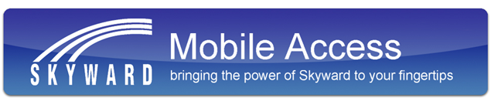
Skyward Mobile Access provides intuitive access for students, parents, and school staff that currently use Skyward’s Family Access, Student Access, Educator Access, or Employee Access. Skyward Mobile Access will automatically locate your district and take you instantly to your vital information such as grades, attendance, discipline, payroll, time off, and more!

